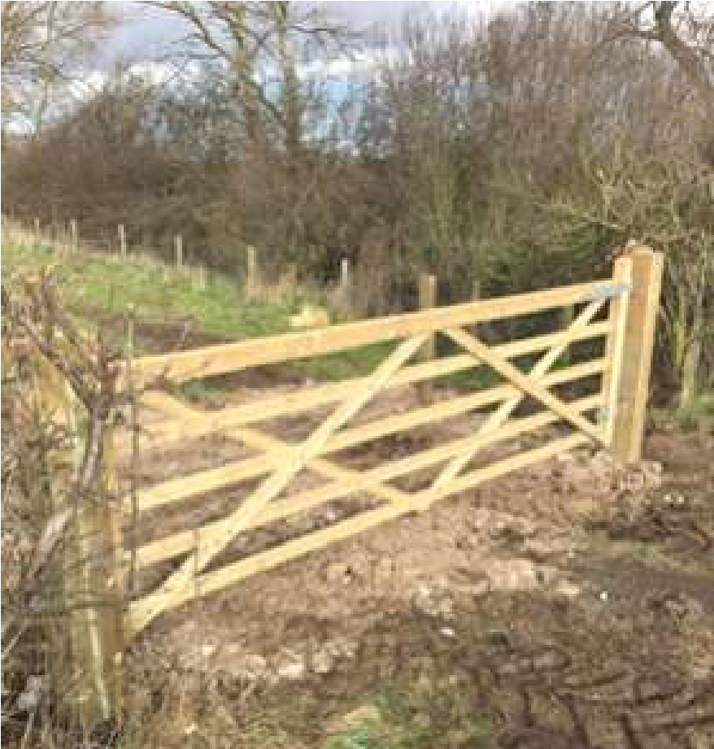

The Newsletter for Middleton on the Wolds

Issue No 36

APRIL 2022

NEXT COPY DATE

14th April

Please send in your contributions by the end of the copy date. If I don’t acknowledge them please get in touch to make sure they have arrived.
I am sure many of you like to exercise your brains with Rowland’s general knowledge quiz but can you let me know which of the other quizzes you like - would you like more sudoku, word wheel or dingbats or do you have any other ideas?
I am pleased to say we have 3 new interesting advertisements this month the income of which will help with our printing costs. Don’t forget to read the latest news in the 2 advertising features - Soanes Poultry and Black Yak.
Lyn
4 The Paddocks 219500 middletonflyer@yahoo.com

ADVERTISING COSTS for the Messenger

Rates Month Year
Whole Page £25 £150
1/2 Page £15 £100
1/3 Page £10 £60

Full colour - Print run 500 copies
Contact: Tina 01377 217242, middletonflyer@yahoo.com
The front page picture is of the new gate into the triangular green community area (see page 15) and was taken by Nick Jones.

Editorial
Another nail in the coffin for rural communities with the decision by East Yorkshire buses to withdraw the No 45 from service. It was, apparently, a purely commercial decision and, seeing the low numbers of passengers using
the service, we can’t be too surprised that it has been pulled. Let’s be honest, this change isn’t going to affect at least 90% of us (in the seven years we’ve lived in Middleton if I’ve caught the bus half a dozen times I’d be surprised); the problem is that, for those who do use it, the bus can be a lifeline.
East Yorkshire Council are looking at the feasibility of providing a replacement service but, as with many things, it depends on the availability of funds. They had hoped to make an announcement by today (March 14th), but I haven’t seen anything, yet.
On a happier note, ‘tis the season to stuff ourselves silly with chocolate!
Happy Easter everyone!
Stay safe,
Mike
If you have any ideas, comments or complaints (especially complaints) you want to share then send an email to middletonflyer@yahoo.com.
Remember, we can’t respond unless we receive your message.
I have recently been informed that our bus service to Driffield is being withdrawn in April, which concerns me as I do not drive. The Prime Minister recently pledged to give more funding to
keep rural communities connected with local towns in order to encourage more people to use public transport and cut pollutants from the atmosphere. This should encourage the local bus company (EYMS) to keep the service going and if anything improve it. I have emailed my comments to Councillor Kevin Beaumont and would ask everyone who has any interest in this situation to do the same. The more people who protest about this the better. The email address is kbeaumont1955@gmail.com
Valerie France

QUIZ PAGE
- In Indian Cuisine is cooked by what method?
- Violet and Veruca are characters in what Roald Dahl novel?
- Claudius poisons the father of which Shakespeare title character?
- Highbury is the former home of what London football team?
- The fabric linen is made from the fibres of what plant?
- What bank did rogue trader Nick Leeson bring down?
What breakfast cereal had the advertising slogan tell them about the
7
honey mummy?
- What's the total number of characters in a National Insurance Number?
- What is the only planet named after a God from Greek mythology?
The Suez crisis followed the American and British decision not to
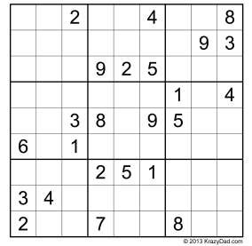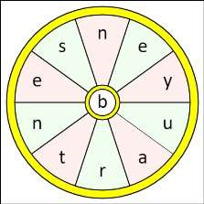Quiz set by Rowland Wooldridge
10

finance what Dam?

All answers on
page 21

Seasonal Word Wheel

Try to find the seasonal character and
then create as many words possible
with the letters in the word wheel. You
can only use each letter once and every
word must include the letter in the
centre of the wheel.

St Andrew’S church

Services for April

Sunday 3rd 10.30am | Morning Prayers C/W
Palm Sunday 10th 10.30am | Holy Communion
 | Rev`d Jane Anderson
Maundy Thursday 7th 7.00pm | Special Service
 | Rev’d Jane Anderson
Easter Day Sunday 17th 10.30am | Holy Communion.
 | Rev`d Cannon Kate Goulder
Sunday 24th 10.30am | Holy Communion.
 | Rev`d Ruth Newton

The wolds METHODIST CHURCH

Services for April
Sunday 3rd 10.30am | Service at the Wolds Methodist Church,
 | Holy Communion, Rev Colin Barrett
Sunday 10th 10.30am | Service at the Wolds Methodist Church
Sunday 17th 6.00am | Sunrise Service at Bainton Burrows Farm,
 | Rev Richard Teal
Sunday 24th 10.30am | Service at the Wolds Methodist Church,
 | Deacon Keith Gough

Local Birds & wildlife
Happy Spring! I think it must definitely be spring now (or by the time you read this anyway) as we have collared doves nesting in our leylandii, and wood pigeons getting frisky (mind you, they tend to frisk quite a lot all year; I imagine they are the sort of birds that would enjoy the more _{Goldfinch} disreputable Christmas office parties).
The collared doves have been working hard for the last few days flying up with totally unsuitable long twigs and trailing bits of grass that mostly get snapped off as they fly into the tree, but today the pair are pottering about on the lawn in the sun together and preening in a “thank goodness we have got the DIY done, now we can relax for a bit” sort of way.
Just after the last newsletter Pat reported that “We have two rabbits filling their faces with grass then dashing off under my shed. So must be feeding babies – hopefully we’ll get to see them. It’s all happening in our garden now the ducks aren’t here, although actually the ducks didn’t bother the rabbits, they often were sitting alongside each other, but just chased the pigeons. We’ve had rabbits nesting under my shed before and the hedgehogs of course. Years ago we had a brace of French partridges (red-legged partridges?- B) who would come up on the deck and look in. Cheeky as you like. Isn’t nature great, especially when you get surprise visitors. They’re all welcome in our garden!”
Our rat (the one I made a point of not mentioning last month) seems to have vanished, so we’ve risked putting fat balls out again; we’ve had long-tailed tits, one solitary starling and one jackdaw enjoying them. Years ago we often had the whole lawn covered with starlings strutting about and probing for worms in winter – too many to easily count – so that is a big change. We do get some starlings perching in a large tree on the other side of Greenfield Road, and on winter evenings they take off and try to do the whole murmuration thing, as seen on TV, but as there is only about ten of them it is a little underwhelming. Very sad.
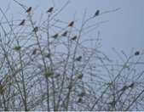
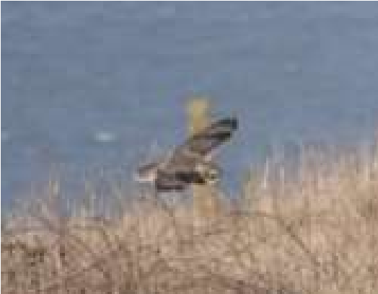
Joanna and Barry have seen birds in larger numbers thank goodness: “Here are some photos that might be of interest. The goldfinches were seen from our dining room window on the large willow tree down the road tonight – this flock was about 50 plus birds – can’t get them all in the picture, we see them most afternoons.” Hazel also reported a large flock of small birds seen on a local walk, but they were too far away to positively identify; she did wonder if they could be goldfinches, so perhaps they were the same flock?
Joanna and Barry also sent a lovely picture of a short-eared owl taken at Bempton Cliffs reserve. Consulting my bird book, although they are marked as being resident all year in our area they do seem to prefer rough ground and moorland to farmed areas, so we would be very lucky to see one around Middleton!
Finally, it is now the time when winter visitors are
leaving, summer birds are arriving, and the birds are singing earlier and earlier in the morning. Exciting times! Please let me know what you have seen locally, and what is going on in your gardens; photos are lovely but it’s nice just to hear from you.
All the best for a great spring and summer, Barbara
lavenderbarbara97@gmail.com text 0777 192 7868
St Andrews Church PCC would like to give a huge Thank You to Roger Lowe for his 27 years of service as a Church Warden. He is stepping down as church warden to enjoy retirement from its duties and a well earned rest. Although I’m sure that will be hard knowing Roger!
Over the years through many changes he has been strong, supportive and overcome many adversities.
On behalf of the PCC, may we wish you well, and say again Thank you so much Roger for all you have done for the congregation of St Andrews.

a note from your vicar
Maundy Money and a Penitent Queen
The Royal Maundy Thursday Service has existed since 600AD with a few changes over the years.
It was custom in England (until the 17th Century) that on Holy Thursday – the day before Good Friday the Monarch would wash the feet of as many of the city’s poor as she/he were years old, thus following the example of Jesus washing the feet of his disciples at
the Last Supper as a symbol and example of servanthood. A silver coin was also given to each person.
Tale tells that the First Queen Elizabeth, when she was 39 years old, did not wish to do this, so instead persuaded her Lady-in-Waiting to dress as queen and perform the ceremony.
As her ‘stand-in’ began to wash the first person’s feet, Elizabeth hid behind a curtain to watch. Now there was a young lad there, Tom Gentry, who was also to have his feet washed. But he was so ashamed that the queen would see his dirty feet that he ran behind the curtain to hide – straight into the arms of his queen!
“Don’t be ashamed” she told him, “Your queen loves you.” She then apologised to everyone for her actions and washed Tom’s feet first, and she gave everyone 2 coins instead of just 1.
Our Queen has travelled to various cathedrals and abbeys over the years to give the Maundy gifts. These days the recipients are nominated by the diocese in recognition of their contributions to the church and community. The distribution of gifts is equal to the number of years the monarch has
lived – this year it will be 96 pence (I wonder what Prince Philip has just said to
worth of money to 96 men and 96 the Bishops!) women.
Each person receives 2 leather purses – one red and one white. The red purse contains coins stamped with her Majesties portrait which has not changed since her coronation in 1953 – this symbolises her gift for food and clothing. Last year a special coin was commissioned to commemorate her 95th birthday and the 50th anniversary of Decimal Day its value was £50.
email: middletonflyer@yahoo.com page
The white purse contains the actual Maundy Money of 4 coins with a monetary value of 50p (though it obviously means far more to those who receive it)
The queen does not wash feet but many of those involved in the service wear a symbolic towel to recall this.
As part of our village celebrations St Andrew’s Church would like to invite you to a special event we will be holding on Friday 3rd & Saturday 4th June 10am – 4pm. And on Sunday 5th we shall also be holding a Service of Thanksgiving for the Queens life and service at 10.30am. More information can be found in this months Messenger. But do please give me a ring if you have any questions.
Jane

Recipe – Easy Jubilee Eaton Mess
5 Meringue Nests
600g (1lb 5oz) Strawberries
2 Tablespoons Icing Sugar
600ml (1.4 Pints) Double Cream
200g (7oz) Soft Berries – red and blue
E.g. Blue Berries, Raspberries, Currants

Method:
- Puree 150g (5 ½ oz) Strawberries and stir in ½ Tablespoon of Icing Sugar.
- Cut the rest of the Strawberries into bite size pieces.
- In a large bowl combine the Double Cream with the remaining 1 ½ Tablespoons of Icing Sugar and whip until it forms soft peaks.
- Take 4 serving bowls or glasses.
- Crumble 4 of the Meringue Nests into the bowl of Whipped Cream.
- Lightly fold in the bite size Strawberries and the Soft Berries.
- Gently stir in the Strawberry Puree.
- Divide between your serving bowls/glasses
- Crumble the 5th Meringue Nest on top of your puds.

It is best to serve these as soon as you put them together as the meringue can become chewy if left in the cream for too long.
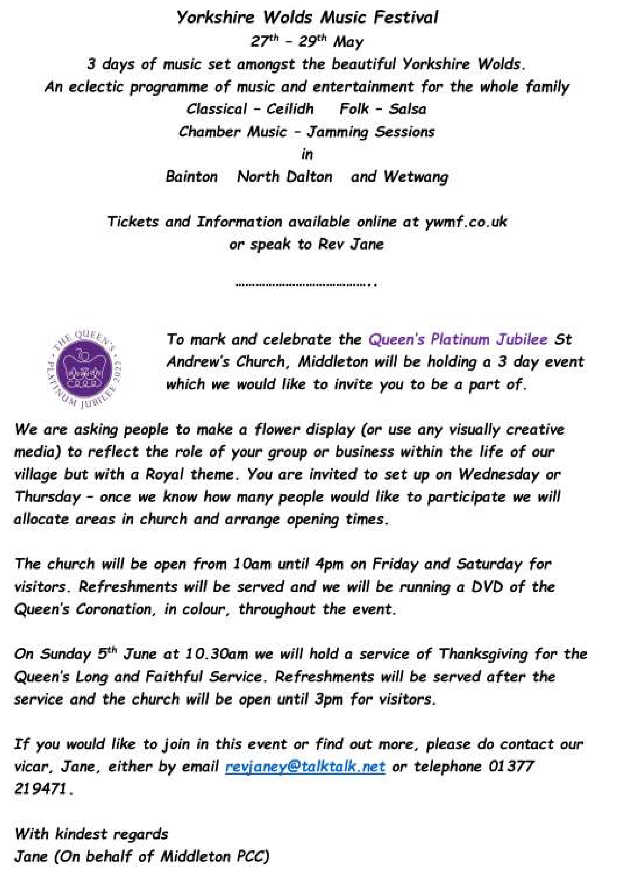

email: middletonflyer@yahoo.com page
12

jubilee celebrations
Thank you to Reverend Jane Anderson for the notification opposite of the events in St Andrew’s
Church over the Jubilee weekend and also Yorkshire Wolds Music Festival.
Posters for the other events planned for the village were in the March issue of the Messenger and there
will be full details again in an edition closer to the time but here is a brief programme for your diaries:
Saturday 28th May, 11.00am Yorkshire Countrywomen’s Association (YCA) are holding a Jubilee Bunting Workshop in the Village Hall £5 or £7.50 for a group of up to 4. Tickets from Linda Jones on 217512
Thursday 2nd June, 12.30pm - Middleton Jubilee Gala at the School
- sports, activities and craft competitions, refreshments tent. See www.middletongala.com for more information or contact Geoff on 07864 855534
Thursday 2nd June, 7.30pm - YCA are hosting “The History Wardrobe’s Fabulous Fifties in the Village Hall. £10 to include a cocktail/mocktail. Tickets from Linda Jones on 217512
Thursday 2nd June, 9.45pm - Lighting of the Jubilee Beacon
Friday 3rd June, 7.30pm - The Village Hall Committee are hosting “An Evening with Edwina Hayes” who sings her own compositions. A light supper is included. Tickets at £10 from Sharon Roe on 217254
Saturday 4th June, 2.00 and 5.00pm - YCA are hosting Afternoon Teas in the Village Hall. Andy Lloyd will entertain with comedy and songs . Tickets are £12, available from Linda Jones on 217512
Sunday 5th June - How about holding your own street party?

parish council news
COMMUNITY PULLS TOGETHER FOR NEW GATE
]]
Following an appeal by the Parish Council the Young Farmers Association together with local businesses recently pulled together to provide a replacement gate within the village. It is intended to turn the ‘Triangular’ Field into a new community and ‘Green’ area and prior to handing the project over to the Green Committee a new gate was needed as the previous one had fallen into disrepair. The gate will allow agricultural and maintenance access to the field, vital for the project going ahead.
Money for the gate was provided by Yorkwold Pigpro Ltd and liaison with S. G. Prescott and Son ensured it was collected, stored and delivered on site. The Young Farmers led by Luke and Nick ( pictured) provided the machinery, expertise and labour required to prepare and install the gate. They also undertook some ground work and removed rubbish and old rotten timbers. Parish Councillors Tina and Nick were on hand to provide words of encouragement and more importantly tea and biscuits!
Five tonnes of Hardcore for the entrance was provided by Ashcourt Aggregates Ltd and it was loaded and delivered by Harvey Training Ltd from Middleton Quarry.
The Parish Council would like to thank all those involved and it was great to see our community coming together for a common cause that will benefit us all. Further work including tree planting can now go ahead and, as reported in last month’s Messenger, a grass path will be created and the council hopes to install a Beacon in the field in time for the Queens Jubilee celebrations in June. Watch this space!
Nick Jones
Parish Councillor
The East Riding Housing Needs Survey is now live!
A chance to tell East Riding of Yorkshire Council about your current home and what the future need for housing might be in your household. Your views as a resident of East Riding are important to us and the information you provide will help us to build a comprehensive picture of the need for homes in our area and help us to ensure we meet the needs of our diverse communities.
The survey can be accessed by the weblink www.tinyurl.com/22HNSS and will take about 7 – 10 minutes. Responses will be anonymous, but we do ask for data about where you currently live to help us to see where the need for homes is. The survey will be open until 22 April 2022.

Middleton recreation ground
These posters are from the dog warden who visited this week as we have had the dreadful task of picking a lot up at the playing fields which is not only for sport but a play area which is a real concern. Also a lot near the embankment grit area. He stated that * Some * dog owners need to take more responsibility and consider other people.

The Recreation Club

LOCAL HISTORY

GEORGE THE FIFTH AND SIXTH
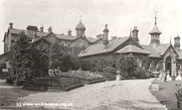
“At the workhouse the inmates, numbering 114 were regaled with ham and eggs and hot cakes for breakfast, together with a distribution of tobacco, tea, sugar sweets etc. and in the afternoon all the inmates who were available, were allowed to visit the Recreation Ground and on their return had tea, the edibles consisting of sweets, plum cakes, cheesecakes, tarts etc.” This
The Poor Law Institution on Bridlington
local press report at the time of the _{Road Driffield}
coronation in 1911 shows the results of falling on hard times at the period when only the first flickerings of the welfare state had appeared and indeed the dreaded workhouse would persist in some form or other until 1948 although the memory of it persisted even longer. The Poor Law Institution on Bridlington Road Driffield, built in 1866 was demolished in recent times.
The summer of 1911 was particularly hot with violent storms in the area and many recorded lightning strikes. As with Edward the seventh’s coronation in 1902 there was no coverage of Middleton’s celebrations but the Driffield
Times reported that “Bainton was all en fete and North Dalton was certainly
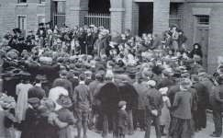
From the beginning the king’s reign was punctuated with problems on the national scene: industrial unrest; women’s suffrage; and Irish Home Rule to name but three. From 1914 the monumental trauma of the First World War and its aftermath shattered the nation’s confidence and the upper classes were not immune. Despite this the modest but shrewd character of the Proclamation of King George V on the steps of king, who had incidentally started a the Market Hall in Market Weighton 1911 Christmas Broadcast to the people in
not lacking on Coronation Day.
”

1932 on the suggestion of the writer Rudyard Kipling, ensured that by his silver jubilee in 1935 he was a much respected head of state and upholder of family values, worthy in the public mind of celebration. On this occasion Middleton’s efforts were not overlooked as recorded in the Driffield Times of the 11th of May:
“Middleton celebrated the Jubilee in royal fashion. There was a children’s parade from the school to the church, where a service was conducted by the rector.The lesson was read by the Rev. R. A. Loten of Driffield. A collection was to the Prince of Wales Fund. A feature of the day was the distribution of tea, tobacco and cigarettes to the old folk. Sports were held in the afternoon and there was maypole dancing. Tea was enjoyed by children in the C.E. school. Mugs were presented by the Rev. E J Wilson and Jubilee Cups were provided by Mrs Noble. About 150 children were recipients. Cheers were given for Mrs Clements who presented each child with a bag of toffee.
Winners of the children’s prizes at the sports were:
GIRLS:
V. Stephens, J. Dunn, B. Lazenby, J. Pickering, P. Horne, K. Welbourne,
J. Noble, V Oxtoby, L. Dove, G. Thompson, A. Burnett, V Ellis, D. Soanes, J. Dooks, H. Lill, E.Oxtoby, A. Gee, J. Eastwood, B. Bentley, J. Ellis,
G. Shipley.
BOYS
R. Foley, J. Swallow, E. Duggleby, W. Stuart, A. Linford, R. Atkinson, G. Wray, D. Thompson, B. Peacock, H. Lazenby, A. Dove, V. Dooks,
D. Horne, H. Lill, R. Wray, R.Potter, D. Sims.
OFFICIALS: STARTS; Messrs W. Dooks and H.Towse.
STEWARDS: The Rev. E. J. Wilson, Dr. E Clements, Mr C. E Mann, Mr. W. Abbot, Mr.W. Eastwood, Mr. J. W. Noble, Mr. L. Powell and Mr D. B. Soanes.
The king who died in 1936 had stated with his customary gruffness that his son Edward, the Prince of Wales who was regarded publicly as a veritable “Prince Charming” with charisma and international popular appeal would ruin himself in twelve months after he acceded to the throne: he did; he abdicated; he married his American double divorcee leaving his nervous but diligent brother Bertie (George) aided by his redoubtable wife Elizabeth to carry the burdens of kingship in times of great stress. This he did.
The well organised Coronation was the first to be broadcast on radio; and locally on the 3rd May 1937 Tom Soanes’ diary entry read “Coronation meeting” and on the 12th “Wet Coronation day had tea in Village Hall.
Football at night.”
The Driffield Times reported “Brave show in dismal weather” and with regard to Middleton: “ A united service, held in the Parish Church which was well attended, was the prologue of a day of merriment in the village. There was a public tea in the Village Hall and the day’s festivities were concluded by a dance in the Village Hall. To commemorate the event the children were presented with silver spoons.”
The years that followed in war- torn Britain and the aftermath were to put a severe strain on the new king which was no doubt a causal factor in his premature death in 1952.
Geoff Wisher

young farmers
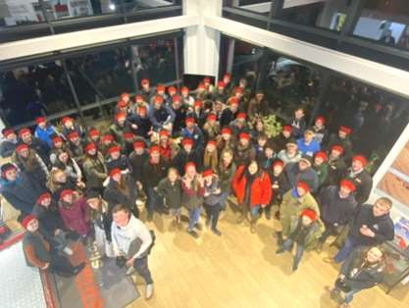
I am a member of Bainton Young Farmers and I love it. We do lots of different activities and have had some very good days out, some of the places we have been to include Allerthorpe Water Park, Grimme, Laveracks, and loads of other places offering fun opportunities.
Something which I think is really valuable is that every few meetings we have a representative from different companies come to our meetings and talk to us about how their businesses work or important things such as farm safety and what to do and what not to do.
Young Farmers is an amazing community where we all look out for each other and if someone is having a bad day then they are easily cheered up by going to a meeting. Through Young Farmers I have met some amazing friends and have had some fantastic opportunities. For example, I was involved in helping with the show jumping at Driffield Show last year. Had I not have been in Young Farmers then I don’t think I would have had this opportunity.
Bainton YFC are aged between 10-28, and meet every Tuesday evening using Middleton Village Hall as their base. For more information contact Bainton.yfc@outlook.com
Lizzy, 14, Press Secretary
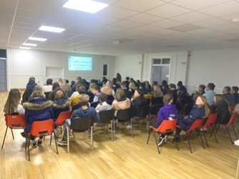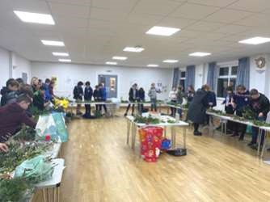

Middleton on the wolds ce ve school
Executive Headteacher: Mrs E Harros
Station Road, Middleton on the Wolds, Driffield YO25 9UQ
E-mail:middleton.primary@eastriding.gov.uk Tel: 01377 217323

Middleton Minis
Our parent, carer, baby and toddler group runs from 1:30 to 3:30pm every
Tuesday afternoon (term time only) at Middleton on the Wolds primary school. Drop in for 20 minutes or the full 2 hours. We look forward to seeing you.

On-going Collections
On-going Collections – We collect used stamps and used batteries. Please note we are not currently collecting used printer cartridges or mobile phones until we can source a new company to collect and recycle them.
We have a Bags2School collection booked for 29th April – just after Easter Holidays.
Easter Bingo is on Wednesday 6th April in the school hall starting at 6.30pm – 8.00pm. You will need to book your tickets with Rachel Brent on 07900675441, Karina Taylor on 07860235894 or Sarah Lowsley on 07743 430584.

Middleton on the Wolds Nursery
At Middleton on the Wolds CE (VC) Primary School
 Providing education for 2, 3 and 4 year olds Monday - Friday.
 We accept the Government’s childcare vouchers for up to 30 hours of free provision for 3 year olds (conditions apply)
 Additional sessions can be purchased for £13.50 per session for 3 year olds and £15.75 for 2 year olds.
 Lunchtime sessions are £1.75 (free if children attend for the whole day) with the option to purchase a school meal for £2.45.
 Children are welcome in the term after their 3rd birthday for funded places.
For further details, please contact: Sharon Stone
Email: middleton.primary@eastriding.gov.uk Tel: 01377 217323

We break up for Easter Holidays on Friday 8th April and return to school on Tuesday 26th April..

Middleton book group

Flappy Entertains by Santa Montefiore Flappy Scott Booth is the queen bee of Barley Compton. Her exacting standards instil fear into the hearts of her 'subordinates'! This is until she comes under the spell of the dashing Charles when standards decidedly slip! A happy, undemanding book which most enjoyed.
The Inheritance by Jenny Éclair. A family saga revolving around Kittiwake, a mansion on the Cornish coast. Peggy, an American heiress restores the house but following the drowning of her eldest son can no longer bear to live there so moves to London. The story follows the history of the house and family culminating in the 50th birthday party of the heir, Lance which ends in tragedy. The book was generally enjoyed by the group.
Pam read some of Henry Brewis, entertaining, farming inspired poems which everyone enjoyed
Lindsay

Meetings are on the second Tuesday in the month. In normal times we meet in member’s homes but in these COVID times we are using village halls. Please get in touch to check.
To find out more about the Book Group please contact Lyn on 219500 or
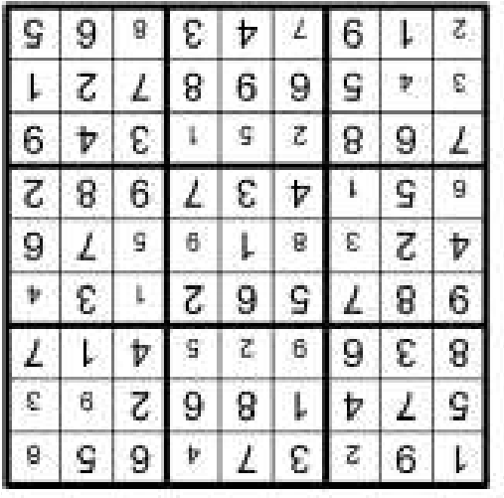

lyndennis456@gmail.com

The next books for discussion are:

Conversations with Friends by Sally Rooney

Hiding in Plain Sight by Susan Lewis

QUIZ ANSWERS

1

Frying

2

Charlie and the Chocolate Factory

3

Hamlet

4

Arsenal

5

Flax

6

Barings

7

Sugar Puffs

8

Nine

9

Uranus

10

Aswan High Dam

Easter bunny

Advertisements

Advertisement

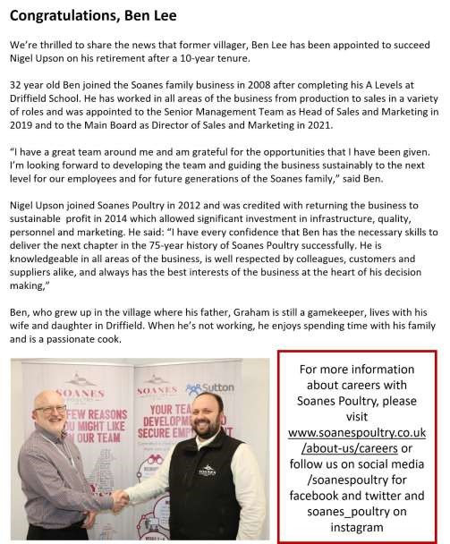
Advertising Feature

Advertisements
Advertisement

Advertising Feature

Regular group activities
Weekly Groups
Monday Pilates 6.00-7.00pm Village Hall Tuesday YCA 2.00-2.40pm Zoom
Tuesday Tai Chi 2.30-4.00pm Village Hall
Wednesday Line Dancing 7.30-9.00pm Village Hall Thursday Middleton Movers 2.00-3.30pm Village Hall

April
4 Parish Council 7.00pm Reading Rooms
6 Village Hall Committee 2.00pm Village Hall
12 Book Group 10.30am Village Hall 17 Litter Picking Wombles 10.00am Lime View
21 YCA 7.30pm Village Hall
LOCAL CONTACTS Bell Ringing Chris Atkin |  | 217285
Book Group/Middleton Movers | Lyn Dennis | 219500
Bowls Club | Rob Bradley | 217435
Country Women’s Association | Christine Johnson | 217374
First Responders | Chris Brent | 219469
Line Dancing | Pat Pottage | 217516
Methodist Chapel | Jane Gray | 07870 562455
Middleton Messenger | Mike Kelly | 07713 620912
 | Lyn Dennis | 219500
 | Tina Walker | 217242
Middleton Womblers | Andrew Naylor | 219072
Parish Clerk | Sandra Morrison | 01262 470496
Pilates | Ian Stephenson | 07973 755717
Reading Rooms | Kath Bentley | 217456
Recreation Club | Dave Newlove | 07901 833784
St Andrew’s Church | Rev Jane Anderson | 219471
St Andrew’s Church Wardens | Chris Brent | 07766 162743
 | Lesley Kelly | O7907 451046
Table Tennis | Louise Newlove | 217801
Village Hall | Lyn Dennis | 219500
Village History | Geoff Wisher | 217517
email: middletonflyer@yahoo.com page 28

